Request Supply Center ordering: To order Supplies electronically go to our website at
http://dnalims.umdnj.edu/.Click on Order MRF Supply Center online link.

Step1:
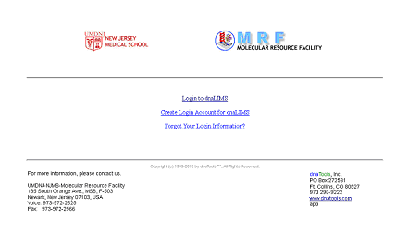
If you know the login name and password click here
If you are a first time user click here and create an account with us. If you don’t see your supervisor in the list please call or email us with all the required information

Step 2: Enter the login name and password

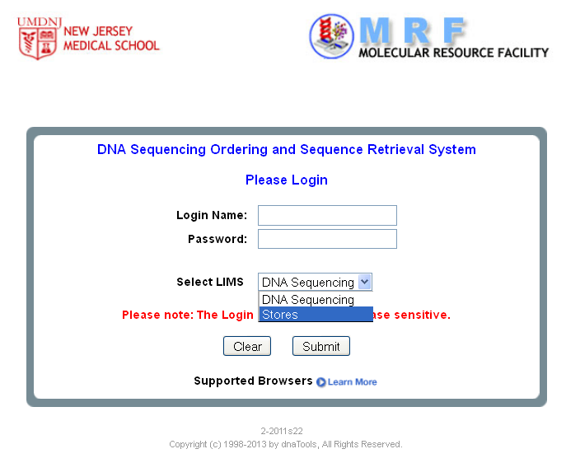

Step 3: Click on Place a New Order or Special Order

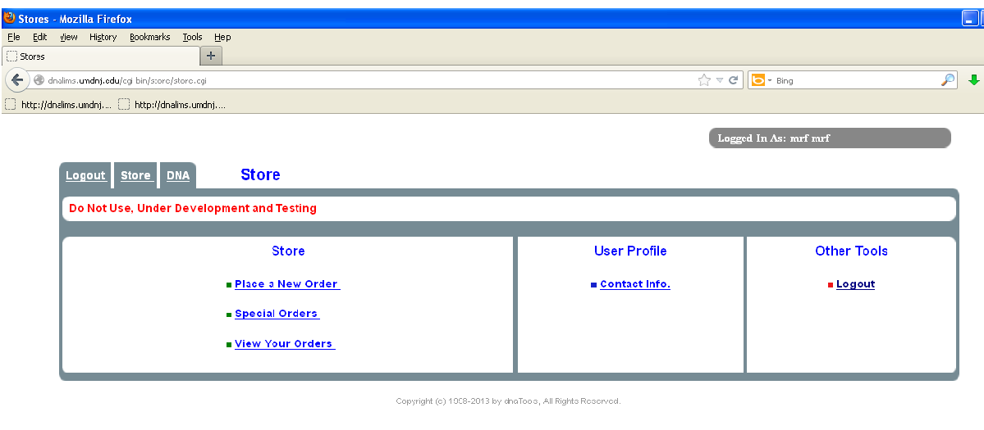
Here you can place a new order (MRF stock items)
Or
Place a Special Order (Not in MRF Stock)

Step 4: Once you select Place a new order

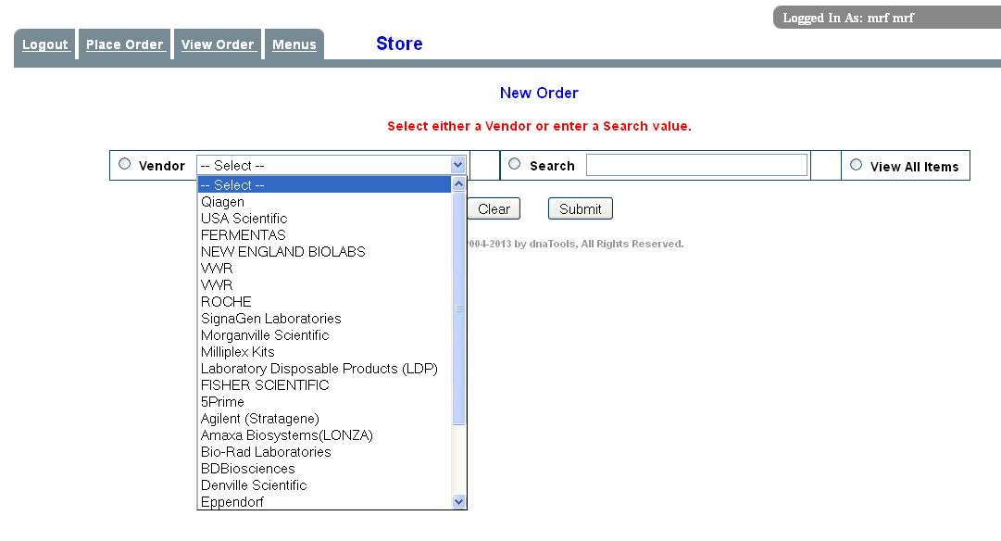
These are all MRF Vendors.
Select desire vendor and hit the submit button or select view all items

Select View all items

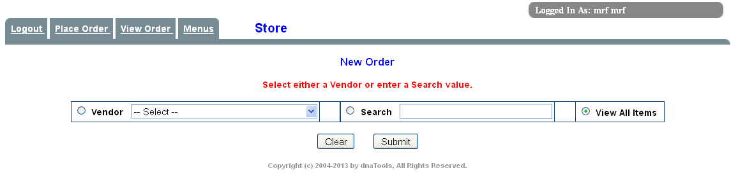
Select View all items.
It will show all vendors

Select multiple vendor’s items and quantity

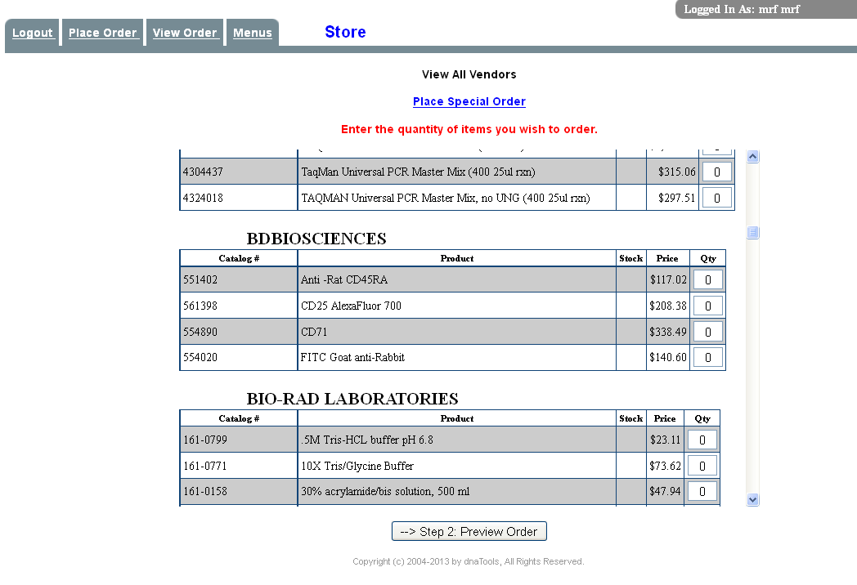
Select the desirable vendor’s

Step 5: Select the product and quantity
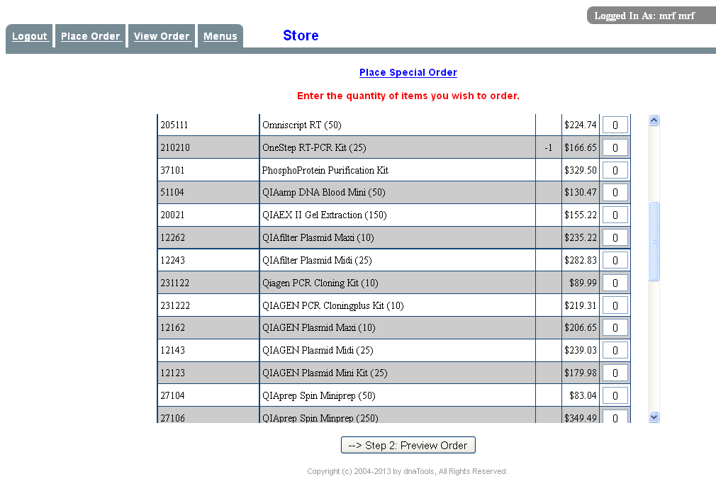
Select the product and quantity then hit the preview order

Step 6: Enter the Lab Id and Index No

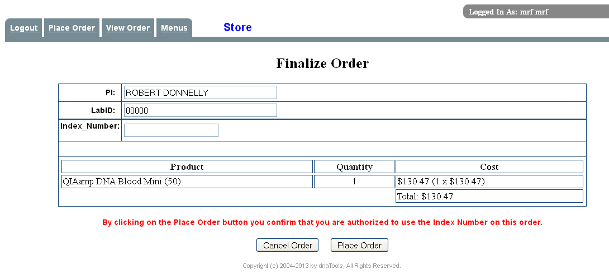
Enter the Lab ID and Index number then place an order

Step 7: Final conformation page
Take print out of this page for your records and bring it with you to pick up your items.

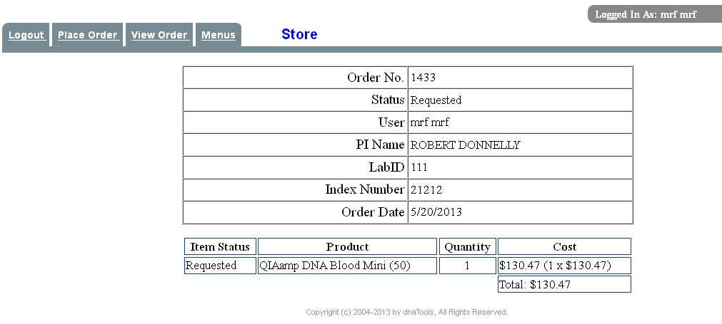

Step1: If it is not in our stock item go to Special Orders

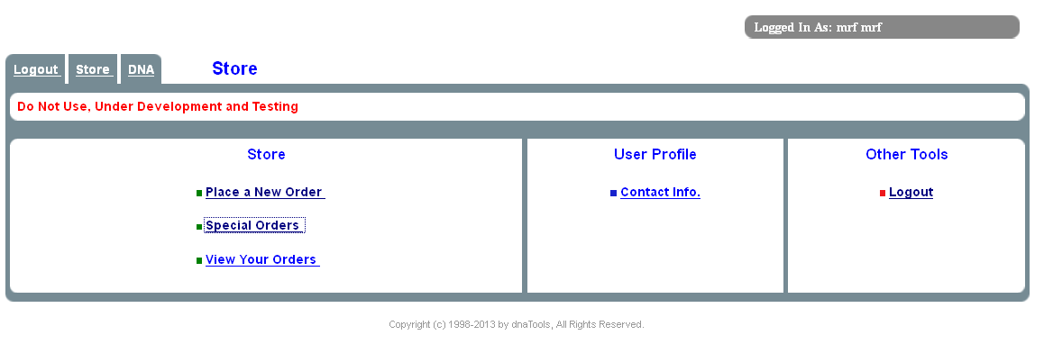
If it is not in MRF Stock item.
You have to select special orders button

Step2: Select the vendor and fill out the cat no, Item name, qty, lab id, index no

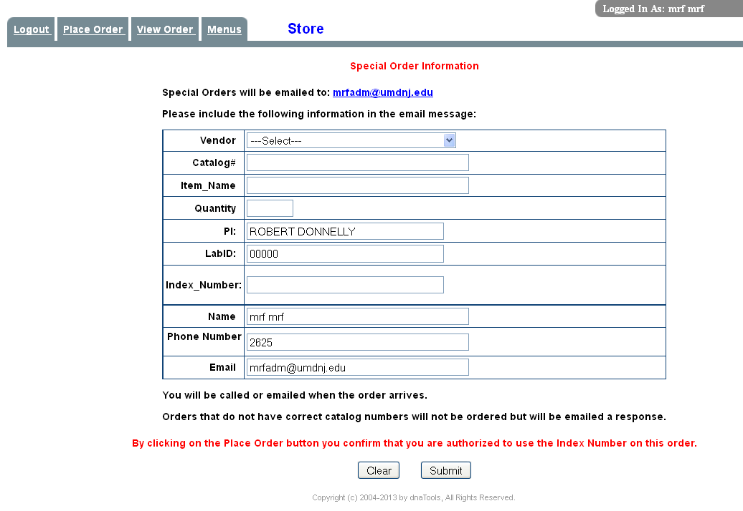

Select the vendor from the drop down button and enter the Cat no and item name and qty and index number
Then
Hit the submit button

Step1: If you want to check the status of an order go to View orders

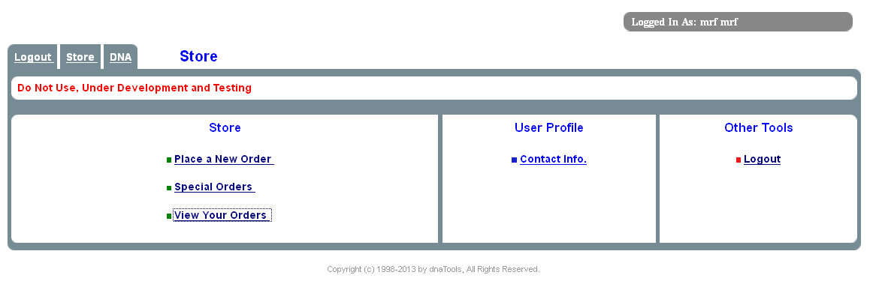
Go to View your orders

Step2: Select the month and status then submit the view usage log

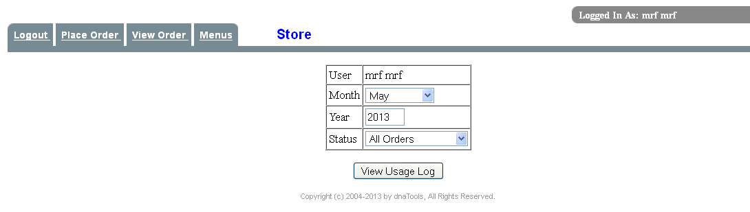
Select the month and status

Step3: View all your orders
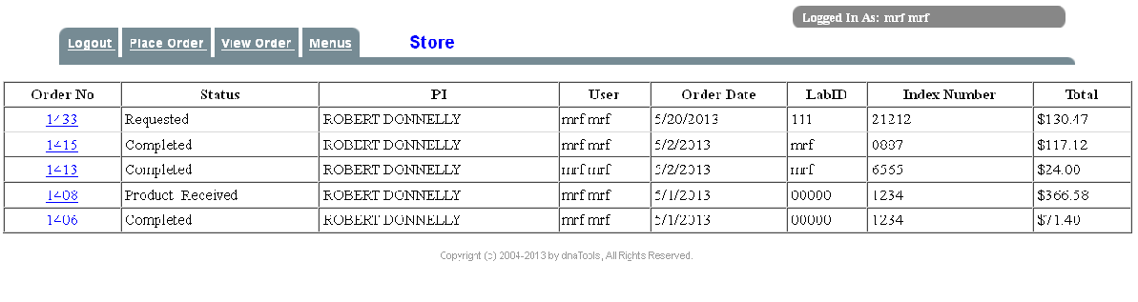
In this page it will show all your orders and price information

Further questions please call at 973-972-2625 or visit our website at http://njms.umdnj.edu/research/mfrweb/.

Note: If you don’t have an account with us, please call us or email us at
mrfadm@umdnj.edu with all the information.

REMEMBER:

-MRF-Supply Center places orders on MONDAY to THURSDAY only for next day pick up.
-All orders must be submitted by 12:30pm to be included for next day pick up.
-All items must be picked up with in one week of the order. After that it will be charged to your account.

